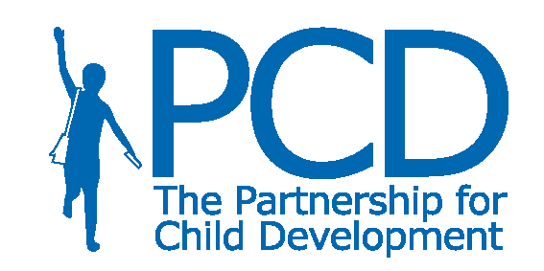
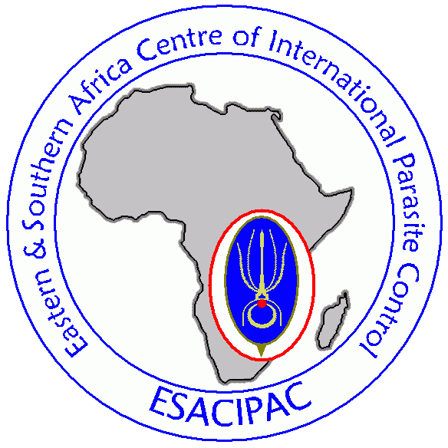

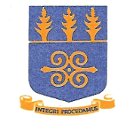
NNIMR

Strengthening Contemporary School Health, Nutrition and HIV Prevention Programmes
Noguchi Memorial Institute for Medical Research
University of Ghana, Accra
8-17th July 2009
LIST OF FACILITATORS
No | NAME | TITLE / ORGANIZATION | ADDRESS | TELEPHONE /FAX/EMAIL
 | Dr Michael Beasley | Director  The Partnership for Child Development | Department of Infectious Disease Epidemiology, Imperial College London, Medical School Building, St Mary’s Campus, Norfolk Place, Paddington, London, W2 1PG, UK | m.beasley@imperial.ac.uk  Tel: +44 207 594 1941  Fax: +44 207 262 7912  Mobile: +44 784 607 8821
 | Dan Ochieng | Consultant  The Partnership for Child Development | P.O Box 8746-00200  Nairobi  Kenya | dkochieng@yahoo.co.uk  Tel: +254 20 3556430  Mobile:+ 254 722 866 865
 | Nicola Lloyd | Administrator  The Partnership for Child Development | Department of Infectious Disease Epidemiology, Imperial College London, Medical School Building, St Mary’s Campus, Norfolk Place, Paddington, London, W2 1PG, UK | nlloyd@imperial.ac.uk  Tel: +44 207 594 1941  Fax: +44 207 262 7912  Mobile: +44 785 775 7476
 | Dr Charles Mwandawiro | Director  ESACIPAC | ESACIPAC-KEMRI, P.O. Box 54840, - 00100 Nairobi  Kenya | cmwandawiro@kemri.org  Tel:+ 254 20 2717521  Fax: + 254 20 2731194
 | Prof Boakye | WACIPAC | NMIMR – University of Ghana  P. O. Box LG 581  Legon – Accra | DBaokye@noguchi.mimcom.org  Tel: + 233 244 54 51 47
 | Dr Irene Ayi | WACIPAC | NMIMR – University of Ghana  P. O. Box LG 581  Legon – Accra | IAyi@noguchi.mimcom.org  Tel: + 233 243 67 04 93
 | Cynthia Kanko | WACIPAC | NMIMR – University of Ghana  P. O. Box LG 581  Legon – Accra | CKanko@noguchi.mimcom.org  Tel: +233-21-501-178 / 9  Mobile: +233 244 969 575

