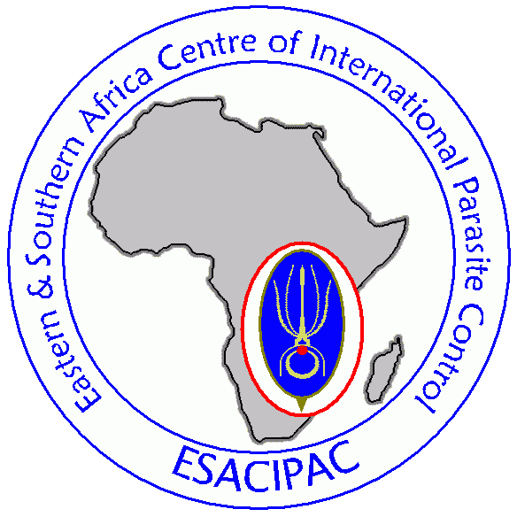



**NNIMR**

**Strengthening Contemporary**

**School Health, Nutrition and HIV Prevention Programmes**

24-31 October 2011 Nairobi, Kenya

**Course Evaluation**

**Guidelines on how to answer this questionnaire:**

We invite you to complete this questionnaire to help us improve our course in the future. Please be frank and open with your ratings and comments. Your opinion—no matter how positive or negative—is valuable to us and will be taken into consideration in the preparation of future activities. To keep your responses anonymous, please do not write your name on the form.

* For ranking items: Please rate the relevant aspects of the course below on a progressive scale of 1 to 5, where **1 is the worst and 5 is the best**. In this scale, 3 is the middle.
* For Yes / No items: Please circle either the ‘yes’ or ‘no’ option depending on which answer you agree with and explain your reasoning when possible.
* Please circle **only one** answer per question.

|  |  |
| --- | --- |
| **Course Aim: To strengthen global, regional, national and local partnerships** | |
|  | |
| 1. Did the course provide opportunities for focused networking with SHN and HIV professionals? | Yes / No  Please describe: |
| 1. Did you develop / strengthen relationships with colleagues of your national and/or regional delegation during the course? | Yes / No  Please describe: |
| 1. Please explain if group work with colleagues assisted you in networking. | Please describe: |
| 1. Did you use any of the contacts you made on the course to gather more information? | Yes / No  Please describe: |
| 1. Do you think that the regional partnerships established during the course will have an impact on your professional activities? | Yes / No  Please describe: |
| 1. Will you be following up with governments and colleagues met through the course, for example through a visit to their country/ programme? | Yes / No  Please describe: |
| 1. Please provide a concrete example of how regional or local partnerships established during the course will enable you to improve implementation of your programmes or area of work? |  |
| 1. Are the regional partnerships established or supported during the course effective in promoting sectoral leadership? | Yes / No  Please describe: |

|  |  |
| --- | --- |
| **Course Aim: To strengthen capacity at the national level of both health and education sectors to support all SHN and HIV prevention programme components.** | |
|  | |
| 1. Are you going to formally share information/learning from the course with your home country team? | Yes / No  If yes, please describe how you may do this:  If yes, please describe with whom you will share: |
|  | |
| 1. Would your country benefit from further assistance in the form of a capacity building course? | Yes / No  If yes, in what particular area of SHN programmes would you benefit from further assistance?  If you would like PCD and the Short Course partners to directly contact you to discuss this assistance please add your contact details here: |
|  | |
| 1. How has your perception of School Health and Nutrition promotion changed during this course? If it has not changed, please describe why. |  |
|  | |
| 1. Please share at least one significant piece of learning that you have taken away from this course. |  |
| **Please rate the relevant aspects of the course below on a progressive scale of 1 to 5, where 1 is the worst and 5 is the best. In this scale, 3 is the middle.** | |
| 1. How useful was the new information you acquired? | |  |  |  |  |  |  |  | | --- | --- | --- | --- | --- | --- | --- | | 1 | 2 | 3 | 4 | 5 |  |  | |
| 1. How useful were the tools, guidelines and frameworks that you acquired during the course? | |  |  |  |  |  |  |  | | --- | --- | --- | --- | --- | --- | --- | | 1 | 2 | 3 | 4 | 5 |  |  | |
| 1. Which were particularly beneficial and why? |  |
| 1. How relevant was the course to your *current* work/functions? | |  |  |  |  |  |  |  | | --- | --- | --- | --- | --- | --- | --- | | 1 | 2 | 3 | 4 | 5 |  |  | |
|  | |
| 1. How relevant did you feel the presentations made by country teams were in assisting you to improve your work plans? | |  |  |  |  |  |  |  | | --- | --- | --- | --- | --- | --- | --- | | 1 | 2 | 3 | 4 | 5 |  |  |   Please describe in what way(s) country presentations were useful/not useful? |
| 1. How useful were the Thematic Groups in providing an opportunity to exchange information? | |  |  |  |  |  |  |  | | --- | --- | --- | --- | --- | --- | --- | | 1 | 2 | 3 | 4 | 5 |  |  |   Please describe: |
| 1. Have you acquired further understanding of implementing good practice? | |  |  |  |  |  |  |  | | --- | --- | --- | --- | --- | --- | --- | | 1 | 2 | 3 | 4 | 5 |  |  |   Please explain: |
| 1. How valuable was the field visit to your understanding of the issues explored in the course? | |  |  |  |  |  |  |  | | --- | --- | --- | --- | --- | --- | --- | | 1 | 2 | 3 | 4 | 5 |  |  | |  |  |  |  |  |  |  | |
| 1. How effective do you feel the field-based teaching / learning around FRESH core components II-IV was? | |  |  |  |  |  | | --- | --- | --- | --- | --- | | 1 | 2 | 3 | 4 | 5 |   Why do you feel field-based learning was effective / ineffective?  How could this be improved in future? |
|  | |
| 1. To what extent did you gain from hearing about different countries’ implementation activities? | |  |  |  |  |  |  |  | | --- | --- | --- | --- | --- | --- | --- | | 1 | 2 | 3 | 4 | 5 |  |  | |
| 1. To what extent did you gain new ideas that will enhance your ability to implement your plan? | |  |  |  |  |  |  |  | | --- | --- | --- | --- | --- | --- | --- | | 1 | 2 | 3 | 4 | 5 |  |  | |
| 1. Do you think that future planning within your country will be improved subsequent to the course? | Yes / No  Please describe: |
| 1. Do you think that future planning across regional networks will be improved subsequent to the course? | Yes / No  Please describe: |
| 1. Has your knowledge of effective evidence-based solutions in other countries benefited your own programme development? | Yes / No  Please describe: |
| 1. Was the course helpful in enabling you to identify the most suitable solutions for your needs? | Yes / No  Please describe: |
|  | |
| 1. Did you identify any gaps in your programmes / work during the course that you were not aware of before? | Yes / No  Please describe: |
|  | |
| 1. Has your M&E knowledge and understanding improved since being on the course? | Yes / No  Please describe: |
| 1. To what extent do you feel able to develop / improve M&E plans for your work subsequent to this course? | |  |  |  |  |  | | --- | --- | --- | --- | --- | | 1 | 2 | 3 | 4 | 5 | |
| 1. Is this an improvement to how able you felt to develop / improve M&E plans prior to attending the course? | Yes / No |

|  |  |
| --- | --- |
| **Course Aim: To provide evidence-based messages for communications and advocacy to build political and financial commitment for the provision of SHN and HIV prevention programmes.** | |
|  | |
| 1. To what extent do you think that the material you received during the course will enable you to motivate additional political interest in this field? | |  |  |  |  |  |  |  | | --- | --- | --- | --- | --- | --- | --- | | 1 | 2 | 3 | 4 | 5 |  |  | |
| 1. Following this course how sufficient do you feel your country’s budget is for effective provision of SHN and HIV prevention programmes? | |  |  |  |  |  |  | | --- | --- | --- | --- | --- | --- | | 1 | 2 | 3 | 4 | 5 |  | |
| 1. To what extent do you think that the technical knowledge acquired during the course will enable you to secure sufficient national SHN&HIV prevention funding? | |  |  |  |  |  |  |  | | --- | --- | --- | --- | --- | --- | --- | | 1 | 2 | 3 | 4 | 5 |  |  | |
| 1. To what extent has the technical knowledge acquired during the course enabled you to better implement your national SHN & HIV prevention activities? | |  |  |  |  |  |  |  | | --- | --- | --- | --- | --- | --- | --- | | 1 | 2 | 3 | 4 | 5 |  |  | |

|  |  |
| --- | --- |
| **Course Facilitation and Administration: Please rate the relevant aspects of the course below on a progressive scale of 1 to 5, where 1 is the worst and 5 is the best. In this scale, 3 is the middle.** | |
| 1. How clear was the teaching by the facilitators? | |  |  |  |  |  |  | | --- | --- | --- | --- | --- | --- | | 1 | 2 | 3 | 4 | 5 |  |   Please describe: |
| 1. Do you feel the facilitation could be improved? How? | Yes / No  Please describe: |
| 1. Were there any sessions that were particularly strong? | Please describe: |
| 1. Were there any sessions that were particularly weak? | Please describe: |
| 1. How organised do you feel the logistical arrangements of the course were? | |  |  |  |  |  |  |  | | --- | --- | --- | --- | --- | --- | --- | | 1 | 2 | 3 | 4 | 5 |  |  |   Please explain: |
| 1. To what extent do you feel the organisation and administrative support could be improved? | |  |  |  |  |  |  |  | | --- | --- | --- | --- | --- | --- | --- | | 1 | 2 | 3 | 4 | 5 |  |  |   Please explain: |
| 1. How satisfied were you with the seminar facilities of the training centre? | |  |  |  |  |  |  |  | | --- | --- | --- | --- | --- | --- | --- | | 1 | 2 | 3 | 4 | 5 |  |  |   Please explain: |

|  |
| --- |
| **Please share any additional comments or suggestions:** |
|  |
| **How satisfied were you with the course overall? Please rate on a scale of 1 to 5, where 1 is not satisfied and 5 is very satisfied.** |
| |  |  |  |  |  | | --- | --- | --- | --- | --- | | 1 | 2 | 3 | 4 | 5 | |
| **How likely would you be to recommend this course to a colleague, with 1 being not at all likely and 5 definitely going to recommend the course?** |
| |  |  |  |  |  | | --- | --- | --- | --- | --- | | 1 | 2 | 3 | 4 | 5 | |

**Thank you for taking the time to complete this evaluation.**

**All the best from the ESACIPAC, WASIPAC and PCD teams!**